H110
Finally, there's the H110 supporting the entry level; here the DMI link between CPU and H110 (PCH) is limited to a slower 5GT/s vs 8GT/s, there's no PCI-Express 3.0, fewer USB devices and only two DIMM slots available on the board limiting upgrade options.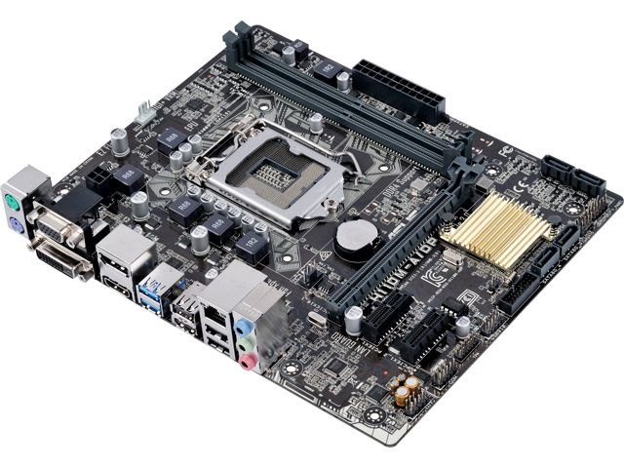
Who needs the H110? Entry level users who want a modern, very efficient and stable PC with a couple of SATA drives and USB peripherals, but aren't concerned to use advanced features or about future upgradability; set and forget. It also serves as an entry level business chipset offering Intel Business Basics, but not Business Advantage.

https://rog.asus.com/articles/maximus-motherboards/whats-the-difference-between-z170-h170-b150-and-h110-chipset-motherboards/

